# CS 255 System Design Document Template

## UML Diagrams

### UML Use Case Diagram

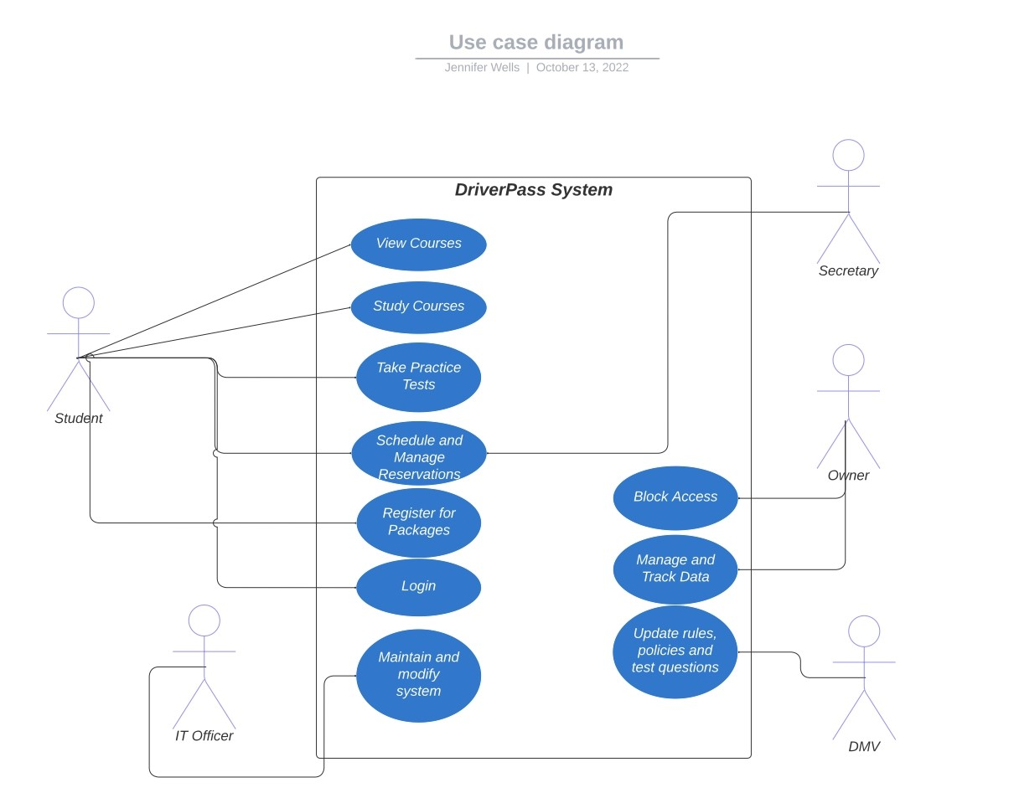

### UML Activity Diagrams

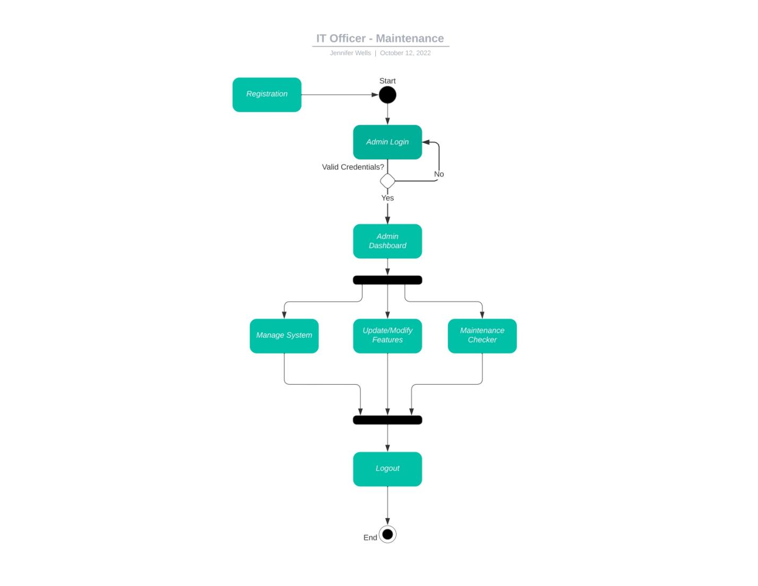

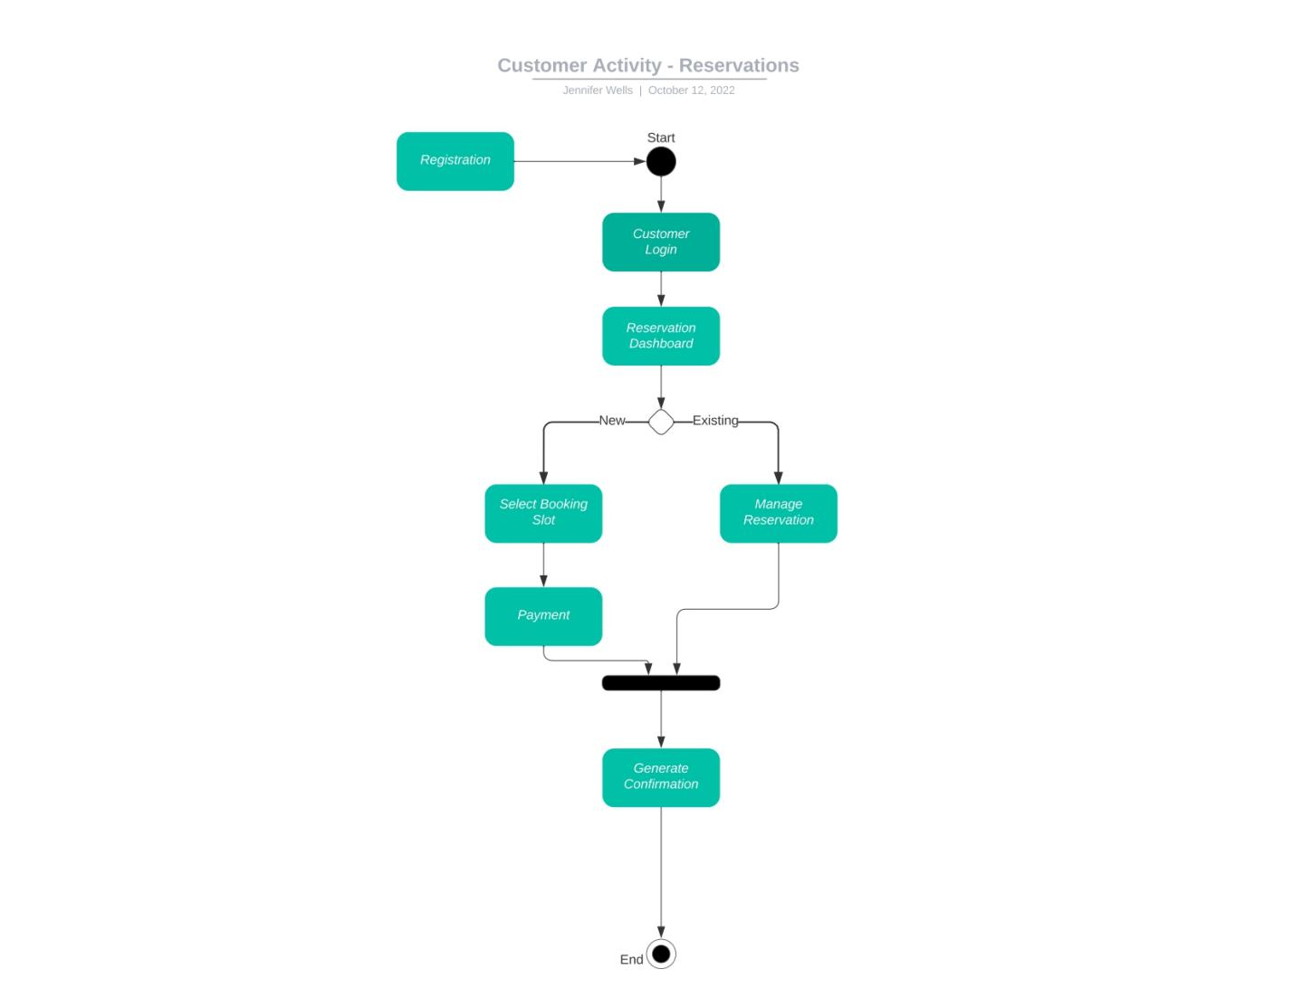

### UML Sequence Diagram

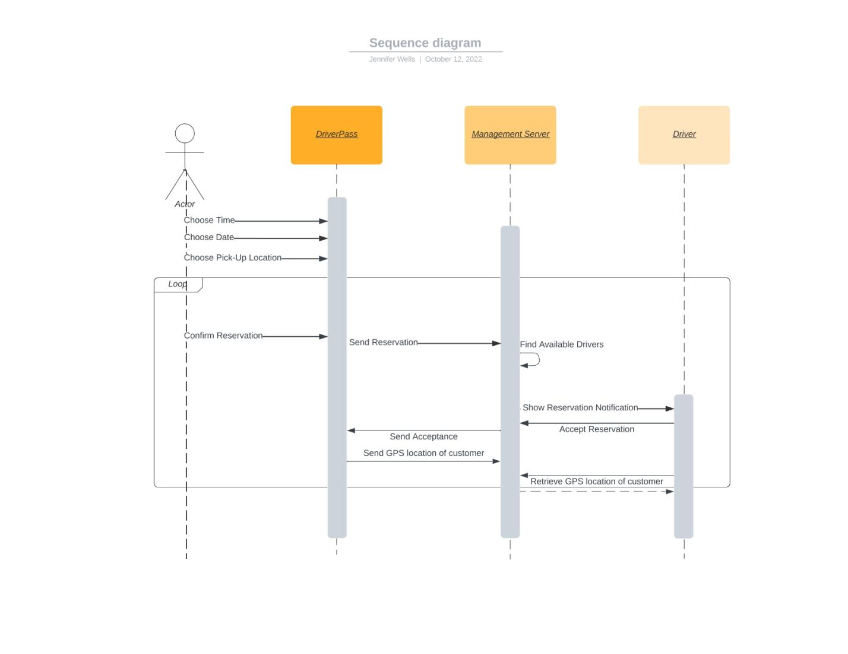

### UML Class Diagram

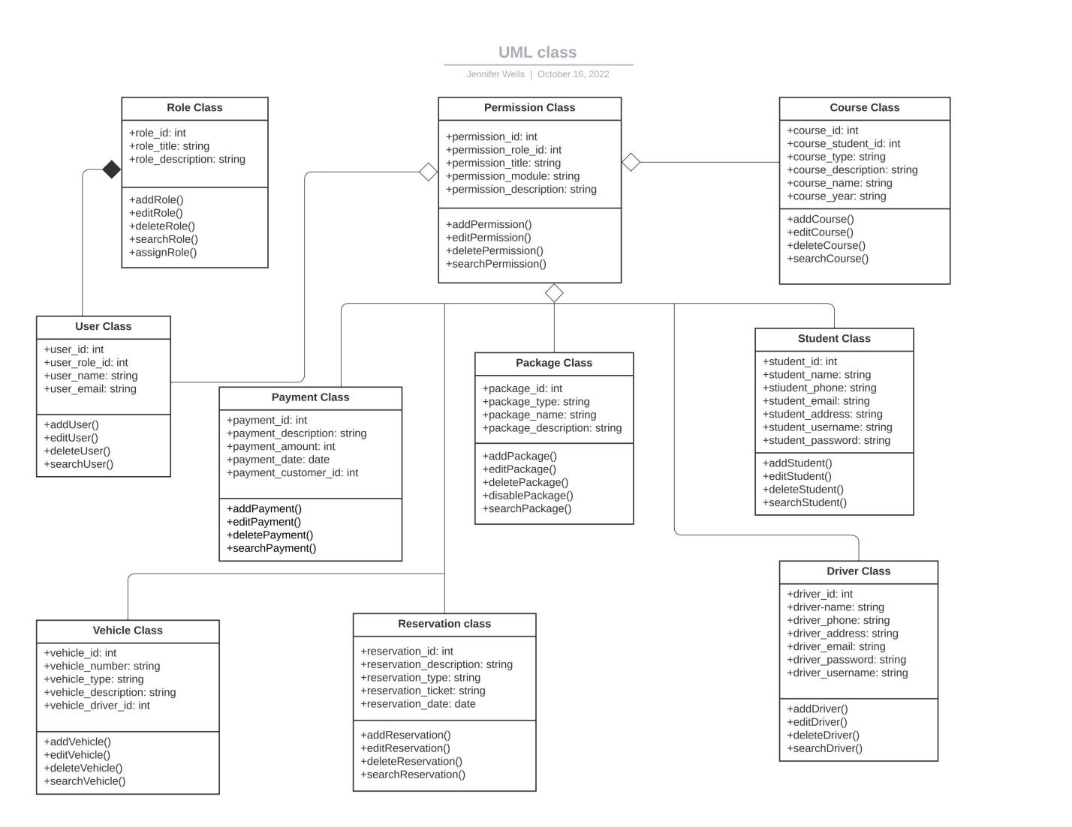

## Technical Requirements

Hardware for Server:

* Processor
* Ram
* Hard Disk Space

Networking:

* Switches
* Routers
* Firewalls
* Storage Arrays
* Backup devices

Software:

Virtualization

* + Hypervisor
* Linux Operating System
* DriverPass system
* Web Server
* Database
* Secure Data Storage
* Security Software
* Payment Processing

System Infrastructure:

* DriverPass system
* Cloud service provider/platform
* Communication Applications
* Electronic Devices
* Internet Accessibility